Application of Data Mining using the K-Means Method for Visitor Grouping

**Rahmayuni Syah1)*, Marnis Nasution2), Irmayanti3)**

1,2,3)Universitas Labuhanbatu, Indonesia

1) [Rahmayunisyah20@gmail.com](mailto:Rahmayunisyah20@gmail.com), 2) [marnisnst@gmail.com](mailto:marnisnst@gmail.com), 3) [irmayantiritonga2@gmail.com](mailto:irmayantiritonga2@gmail.com),

**Submitted** :April 4, 2024 | **Accepted** : April 15, 2024 | **Published** : April 22, 2024

**Abstract:** Grouping amusement ride visitor data is an important process that aims to identify certain patterns of visitors, enabling management to adjust marketing strategies and improve their services more effectively. This process begins with a data selection stage where relevant visitor data is collected and prepared for analysis. The next stage is data pre-processing, which involves cleaning the data from noise or irrelevant data, as well as ensuring the data is in a format suitable for analysis. After that, the data mining model design is carried out by selecting the most appropriate method for grouping visitor data. The next stage is testing and evaluating the model to verify its accuracy and effectiveness. The results of model testing show that visitor data can be categorized into three groups: C1 with 50 data, C2 with 20 data, and C3 with 48 data. The results of the model evaluation confirm that the designed model succeeded in classifying data with perfect accuracy, namely 100%. This success shows that the model is highly effective in identifying and segmenting visitor patterns, providing valuable insights for strategic decision making in service improvement and marketing. This success also opens up opportunities for the application of similar methods to other datasets in an effort to improve visitor experience and operational efficiency.

**Keywords:** Clustering; Confusion Matrix; Data Mining; K-Means; Scatter Plot

# **INTRODUCTION**

Playgrounds are places where children and adults can enjoy various types of games and activities that are exciting and full of challenges. Usually located in amusement parks or recreation centers, rides offer a variety of attractions, from classic games such as swings and slides, to modern and sophisticated rides such as roller coasters, haunted houses and simulators. Each ride is designed to provide different sensations and experiences, with the main aim to entertain and stimulate visitors' adrenaline. Apart from that, playgrounds also often provide supporting facilities such as eating areas, souvenir shops, and rest zones, making them the perfect destination for families and friends who want to spend time together while enjoying the fun and excitement. On every playground, the presence of visitors is an important element that gives life and dynamics to the ride. Visitors come from various backgrounds and ages, bringing their enthusiasm and excitement to try the various attractions on offer. Interaction between visitors, whether it's excitement while waiting for their turn, screams full of adrenaline while enjoying the rides, or laughter after completing a game, adds to the lively and lively atmosphere in an amusement park. Their presence not only fills the rides with diverse stories and experiences, but also encourages managers to continue to innovate and maintain the rides so that they remain attractive and safe for everyone. In this way, visitors and playgrounds provide each other with value and unforgettable memories, creating a positive circle of entertainment and satisfaction.

In the world of amusement parks, visitor safety and security should be a top priority. However, sometimes there are still errors that visitors and ride owners may not immediately realize. Each playground is designed to specific specifications targeting visitor demographics based on age, gender and height to ensure their safety and comfort. For example, rides designed for toddlers typically have lower speeds, shorter routes, and fewer obstacles than rides for older children or adults. Unfortunately, sometimes errors occur when using this vehicle. For example, rides that should be specifically for toddlers are sometimes also used by children over 5 years old. This can be problematic because bigger, heavier children can accidentally cause damage to the ride or even harm themselves or other smaller children. In addition, overloading or use that does not comply with regulations can reduce the effectiveness of the ride's safety system, thereby increasing the risk of accidents.

Every ride in an amusement park is designed taking into account various safety aspects, including the age categories of visitors who are allowed to use them. This is done to ensure that every visitor, especially children, can enjoy the rides safely without risk of injury. These age categories are not just guidelines, but are the result of rigorous research and testing to assess the safety of rides for various age groups. Age restrictions on rides are important because younger children may not have enough physical strength, height, or mental maturity to handle the challenges presented by some attractions. For example, rides that move quickly or that involve significant heights may not be safe for young children. In addition, the safety systems on these rides are often designed to protect bodies that have reached a certain size and weight, so children who are too small may not be properly protected in the event of an accident. Therefore, it is very important for theme park managers to strictly enforce and monitor these age restrictions. Parents and caregivers must also pay attention to and comply with these rules for the safety of their children. Educating visitors about the importance of these restrictions is also an important part of safety efforts, to avoid unwanted incidents. Proper management of these rules not only ensures visitor safety but also improves the overall experience at a theme park, making it a fun and safe place for all visitors, regardless of their age.

Therefore, it is very important to group or cluster visitors based on age, gender and weight for each playground. This clustering ensures that every child using the rides is in the appropriate category, thereby increasing safety and reducing the risk of injury. By using data mining methods, amusement park managers can effectively identify and group visitors into homogeneous groups. This process not only makes it easier to enforce rules relating to age restrictions and physical specifications, but also helps in customizing a safer and more enjoyable gaming experience for each visitor, based on their physical characteristics and needs. This is a strategic move in theme park management aimed at maximizing visitor satisfaction while maintaining high safety standards. Implementing this clustering not only improves security but also allows theme parks to offer a more personalized experience. For example, by grouping together children who have similar physical characteristics, amusement parks can optimize the setup and operation of rides to better suit certain age or weight groups. This means that each ride can be customized to provide the right level of excitement and ensure that the experience is safe and enjoyable for each group of visitors. In addition, with more structured and organized data, managers can more easily identify the need for adding or modifying new rides, based on visitor preferences and safety, making amusement parks more innovative and responsive to the needs of their visitors.

In an effort to improve security and safety at the Happy Kiddy Playground, as well as to provide a more personal and enjoyable experience for each visitor, the author wishes to conduct research which aims to group visitors based on certain characteristics. The method chosen for this research is K-Means, which is a popular algorithm in the field of Data Mining for grouping or clustering. The K-Means algorithm works by dividing data into a number of groups (k clusters) based on certain features, by optimizing the distance between data points in one group and maximizing the distance between groups. This research is expected to identify certain patterns in the preferences and characteristics of visitors to the Happy Kiddy Playground. By using the data that has been collected, such as age, gender, height, and the most frequently visited rides, the author plans to group visitors into several clusters that have certain characteristics. For example, clusters can be formed based on age groups, with the aim of better understanding what types of rides are most suitable and safe for each age group. This will not only increase visitor safety but can also help ride managers provide attractions that are more appropriate and attractive for each group of visitors.

By applying the K-Means Method to Data Mining, this research also aims to provide recommendations to Happy Kiddy Playground managers on how to optimize resource distribution and promotions for the most relevant demographic targets. For example, if it is identified that a certain cluster tends to visit more adventure rides, then managers can increase investment in that type of ride or develop promotions targeted at the appropriate demographic group.

# **LITERATURE REVIEW**

Data mining is an analytical process designed to explore data (usually big data containing previously unknown patterns, relationships or associations) on a large scale (Abas et al., 2023) (Saputra, Hindarto, & Haryono, 2023) (Bustomi, Nugraha, Juliane, & Rahayu, 2023). The main goal is to extract useful information from large data sets and convert it into an understandable structure for subsequent use. This technique involves methods from statistics, machine learning, and database systems (Aji & Devi, 2023) (S. A. Hasibuan, Sihombing, & Nasution, 2023). By using data mining, businesses and organizations can make more informed decisions based on trends and patterns found in their data, such as customer behavior predictions, market analysis, and risk management (Pratama, Yanris, Nirmala, & Hasibuan, 2023) (Sinaga, Marpaung, Tarigan, & Tania, 2023). In practice, data mining is often used to identify unexpected relationships and predict future trends, which can provide a competitive advantage for a business or organization. For example, in the retail industry, data mining can be used for shopping cart analysis to identify combinations of products that are frequently purchased together by consumers. In the financial sector, this technique can help in fraud detection by identifying unusual transaction patterns. The data mining approach involves various stages, including data selection and pre-processing, model selection, model evaluation, and interpretation of results, all aimed at gaining accessible insights from the data.

# **METHOD**

The K-Means method is one of the most popular and widely used clustering techniques in data mining and machine learning, which aims to partition n observations into k clusters where each observation is included in the cluster with the closest mean, thereby minimizing the variance in the cluster (Aldo, 2023) (Andi, Juliandy, & David, 2023) (Wijaya, Dharma, Heyneker, & Vanness, 2023). This technique begins by randomly selecting k points, known as centroids, as starting points for each cluster, and then repeats the step of assigning each observation to the closest cluster based on the Euclidean distance and updating the cluster centroids until the stopping criterion is met (Indah, Sari, & Dar, 2023) (Asriningtias, Wulandari, Persijn, Rosyida, & Sutawijaya, 2023). K-Means is used to analyze unlabeled data and is often applied in various practical applications such as market segmentation, document clustering, and image analysis, due to its efficient ability to handle large data sets. The stages that can be used in this research are as follows.

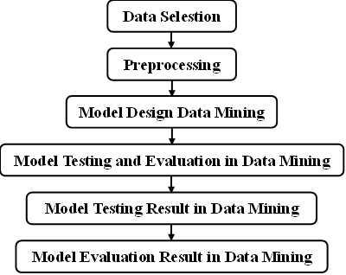

**Fig 1. K-Means Model Framework**

An explanation of each stage is as follows.

Data Selection : Data selection involves gathering and preparing the relevant visitor data for analysis, which is a critical first step in the process of segmenting visitors to the Happy Kiddy amusement park for targeted improvements and marketing strategies.

Preprocessing : Preprocessing involves cleaning and organizing the data to ensure it is free from inconsistencies and ready for further analysis.

Model Design Data Mining : The design of the data mining model for clustering aims to group data into several groups or clusters based on similar characteristics, so that more structured information can be produced from large and complex datasets.

Model Testing and Evaluation in Data Mining : Model Testing Results in Data Mining The results of testing clustering models in data mining show the model's ability to accurately group data into homogeneous groups, based on similar characteristics.

Model Evaluation Result in Data Mining : The evaluation results of cluster models in data mining show the level of accuracy and efficiency of the model in grouping data into relevant clusters, enabling more precise decision making based on identified patterns and trends.

In the context of clustering, a confusion matrix can be used to measure how well a model differentiates and groups data into the correct clusters, by comparing the clusters predicted by the model to the actual clusters assigned via external methods (Mawaddah, Dar, & Yanris, 2023).

Table 1. Confusion Matrix

|  |  |  |  |
| --- | --- | --- | --- |
|  | **Prediction Class** | | |
| **Attribute Class** | **Class** | **True** | **False** |
| True | True Positive (TP) | False Positive (FP) |
| False | False Negative (FN) | True Negative (TN) |

Where table 1 contains:

1. TP (True Positive), namely the amount of positive data that has a true value.
2. TN (True Negative), namely the amount of negative data that has a true value.
3. FN (False Negative), namely the amount of negative data but which has the wrong value.
4. FP (False Positive), namely the amount of data that is positive but has the wrong value.

Accuracy for clustering measures how closely the clusters formed by the model correspond to the original divisions or groups of the data, reflecting the effectiveness of the model in grouping similar data (Siregar, Irmayani, & Sari, 2023). Accuracy Value Formula:

$Acuracy=\frac{TP+TN}{TP+TN+FN+FP}$**× 100%**

Precision in the context of clustering measures the proportion of data that is classified into a cluster correctly compared to the total data that is classified into that cluster (Sari, Yanris, & Hasibuan, 2023). precision can be obtained using the formula:

$$Presisi=\frac{TP}{TP+FP} ×100\%$$

Recall is used to indicate the number of perpetrators from positive category data that were correctly classified (F. F. Hasibuan, Dar, & Yanris, 2023). To find the Recall value, use the formula:

$$Recall=\frac{TP}{TP+FN} ×100\%$$

# **RESULT**

## Data Selection

This stage is the stage carried out to obtain data. The data that has been obtained will later be used as research sample data. The data that has been obtained is as follows.

Table 2. Research Sample Data

|  |  |  |  |  |
| --- | --- | --- | --- | --- |
| **Visitor Name** | **Age** | **Gender** | **Height** | **Category** |
| Adi Baskara Putra | 6 | Man | 125 | Children |
| Aisyah Putri Damar | 9 | Woman | 132 | Children |
| Akbar Rizky Maulana | 8 | Man | 132 | Children |
| Aldo Bima Seno | 7 | Man | 128 | Children |
| Alifia Cinta Dewi | 5 | Woman | 117 | Toddler |
| Bagus Rayhan Aditya | 9 | Man | 132 | Children |
| Bella Sari Dewi | 8 | Woman | 130 | Children |
| Bilal Aditya Rahman | 8 | Man | 131 | Children |
| Bima Dwi Cahya | 7 | Man | 128 | Children |
| Bintang Rizki Fauzan | 7 | Man | 128 | Children |
| Cahya Putri Ramadani | 8 | Woman | 130 | Children |
| Cakra Wijaya Putra | 8 | Man | 130 | Children |
| Cinta Ayu Lestari | 8 | Woman | 131 | Children |
| Citra Kirana Sari | 7 | Woman | 128 | Children |
| Clara Putri Ayudia | 9 | Woman | 134 | Children |
| Daffa Rizaldi Putra | 8 | Man | 130 | Children |
| Dara Intan Permata | 6 | Woman | 123 | Children |
| Dewa Gita Asmara | 8 | Woman | 130 | Children |
| Dika Jaya Purnama | 6 | Man | 123 | Children |
| Dina Ayu Safitri | 9 | Woman | 132 | Children |
| Edo Baskoro Yudhoyono | 6 | Man | 123 | Children |
| Eka Putra Bramantyo | 8 | Man | 130 | Children |
| Elang Rajasa Bayu | 7 | Man | 127 | Children |
| Elisa Nur Aisyah | 7 | Woman | 129 | Children |
| Elsa Laila Sari | 9 | Woman | 132 | Children |
| Fadil Jaya Kurniawan | 7 | Man | 126 | Children |
| Fajar Nugraha Putra | 9 | Man | 132 | Children |
| Farah Dian Sari | 8 | Woman | 129 | Children |
| Fikri Jaya Setiawan | 6 | Man | 123 | Children |
| Fitri Hana Sari | 7 | Woman | 128 | Children |
| Galih Arjuna Wibowo | 9 | Man | 140 | Children |
| Ghina Fadhila Yani | 7 | Woman | 128 | Children |
| Gilang Ramadhan Putra | 7 | Man | 128 | Children |
| Gina Ayu Kusuma | 6 | Woman | 123 | Children |
| Giska Putri Illahi | 7 | Woman | 128 | Children |
| Hadi Surya Baskoro | 7 | Man | 128 | Children |
| Hana Mei Lestari | 4 | Woman | 100 | Toddler |
| Hanif Rahmat Pratama | 7 | Man | 128 | Children |
| Haris Ahmad Syukur | 8 | Man | 128 | Children |
| Hesti Arum Sari | 7 | Woman | 128 | Children |
| Ika Melati Indah | 7 | Woman | 128 | Children |
| Ikbal Fikri Hidayat | 9 | Man | 133 | Children |
| Indra Bima Yudha | 6 | Man | 123 | Children |
| Intan Permata Suci | 7 | Woman | 128 | Children |
| Irfan Zaky Maulana | 8 | Man | 130 | Children |
| Jaya Kurnia Dewanto | 7 | Man | 128 | Children |
| Jihan Ayu Pertiwi | 9 | Woman | 132 | Children |
| Jihan Putri Maharani | 7 | Woman | 127 | Children |
| Joko Tri Hariyanto | 8 | Man | 130 | Children |
| Julita Rani Kumala | 5 | Woman | 117 | Toddler |
| Kafi Adi Pratama | 4 | Man | 103 | Toddler |
| Kamilia Putri Indah | 5 | Woman | 117 | Toddler |
| Kania Tiara Putri | 8 | Woman | 131 | Children |
| Keisha Putri Amalia | 8 | Woman | 130 | Children |
| Kirana Dewi Salsabila | 9 | Woman | 132 | Children |
| Laila Cinta Damayanti | 4 | Woman | 103 | Toddler |
| Liana Dewi Sukmawati | 3 | Woman | 93 | Toddler |
| Lintang Senja Pratama | 4 | Man | 102 | Toddler |
| Lutfi Aziz Karim | 5 | Man | 117 | Toddler |
| Luthfi Ahmad Syahputra | 9 | Man | 132 | Children |
| Mahesa Jaya Kusuma | 5 | Man | 115 | Toddler |
| Malik Arjuna Putra | 5 | Man | 117 | Toddler |
| Maudy Ayu Kusumawati | 3 | Woman | 94 | Toddler |
| Mika Anggun Permata | 5 | Woman | 117 | Toddler |
| Mirza Akbar Fauzi | 4 | Man | 103 | Toddler |
| Nadia Putri Zahra | 3 | Woman | 88 | Toddler |
| Nanda Rizki Pratama | 4 | Man | 103 | Toddler |
| Nia Sari Wulandari | 6 | Woman | 126 | Children |
| Niko Aditya Putra | 5 | Man | 117 | Toddler |
| Nila Sari Dewi | 3 | Woman | 87 | Toddler |
| Oka Mahendra Putra | 2 | Man | 75 | Toddler |
| Olivia Putri Hartanti | 3 | Woman | 89 | Toddler |
| Olla Ramlan Sari | 6 | Woman | 123 | Children |
| Opan Jaya Kusuma | 6 | Man | 124 | Children |
| Ovi Dwi Astuti | 5 | Woman | 117 | Toddler |
| Prita Kinanti Ayu | 2 | Woman | 76 | Toddler |
| Puspa Indah Permata | 8 | Woman | 129 | Children |
| Putra Mahkota Rizal | 5 | Man | 117 | Toddler |
| Putri Ayu Andini | 6 | Woman | 123 | Children |
| Putu Bagus Santoso | 6 | Man | 123 | Children |
| Qaisar Alif Ramadhan | 6 | Man | 122 | Children |
| Qiara Zafira Husna | 6 | Woman | 123 | Children |
| Qila Zahra Putri | 2 | Woman | 75 | Toddler |
| Qisthi Aulia Rahman | 8 | Woman | 130 | Children |
| Qonita Laila Kurniawan | 6 | Woman | 123 | Children |
| Rafi Alifian Putra | 6 | Man | 121 | Children |
| Rama Aditya Pratama | 2 | Man | 78 | Toddler |
| Rian Dwi Saputra | 6 | Man | 123 | Children |
| Ridho Bayu Aji | 7 | Man | 125 | Children |
| Rizki Fajar Nugroho | 8 | Man | 130 | Children |
| Salsa Bintang Pratiwi | 6 | Woman | 123 | Children |
| Sari Nindya Ayu | 7 | Woman | 128 | Children |
| Sasa Tiara Indah | 8 | Woman | 130 | Children |
| Sinta Bella Ratri | 2 | Woman | 77 | Toddler |
| Tara Bintang Alam | 2 | Man | 76 | Toddler |
| Tasya Kamila Putri | 7 | Woman | 128 | Children |
| Tegar Bayu Pratama | 6 | Man | 123 | Children |
| Tiara Putri Ananda | 7 | Woman | 128 | Children |
| Ujang Budi Setiawan | 7 | Man | 128 | Children |
| Uki Dwi Saputra | 8 | Man | 135 | Children |
| Umar Zaki Nugroho | 2 | Man | 79 | Toddler |
| Umi Salma Farida | 7 | Woman | 128 | Children |
| Vania Kirana Dewi | 6 | Woman | 123 | Children |
| Vega Arjuna Wisnu | 7 | Man | 128 | Children |
| Vino Bastian Harahap | 8 | Man | 130 | Children |
| Vira Ayu Kirana | 3 | Woman | 86 | Toddler |
| Wafi Aditya Rahman | 6 | Man | 123 | Children |
| Winda Ayu Larasati | 6 | Woman | 123 | Children |
| Wira Yudha Pratama | 8 | Man | 130 | Children |
| Wulan Dari Rahayu | 4 | Woman | 103 | Toddler |
| Yasmin Nadira Putri | 9 | Woman | 132 | Children |
| Yasmine Putri Zahra | 6 | Woman | 123 | Children |
| Yogi Pratama Akbar | 6 | Man | 123 | Children |
| Yuda Pratama Surya | 6 | Man | 123 | Children |
| Zahra Nabila Putri | 6 | Woman | 123 | Children |
| Zaki Ahmad Fauzi | 9 | Man | 132 | Children |
| Zara Putri Anjani | 7 | Woman | 128 | Children |
| Zidan Ali Marwan | 7 | Man | 126 | Children |

In the table above is the data that has been obtained, the data above is data on visitors to the Happy Kiddy Playground. The description attribute is a grouping target which will later be analyzed using the K-Means method.

## Preprocessing

At the preprocessing stage, the data will be analyzed and cleaned if there is data that is not suitable for use. At this stage the data will also be arranged in a good format and form so that the data can be used in the clustering process using the K-Means method.

## Model Planning on Data Mining

This stage is the design stage of the model created in Data Mining. The software that will be used is Orange Software. This design process uses the K-Means method.

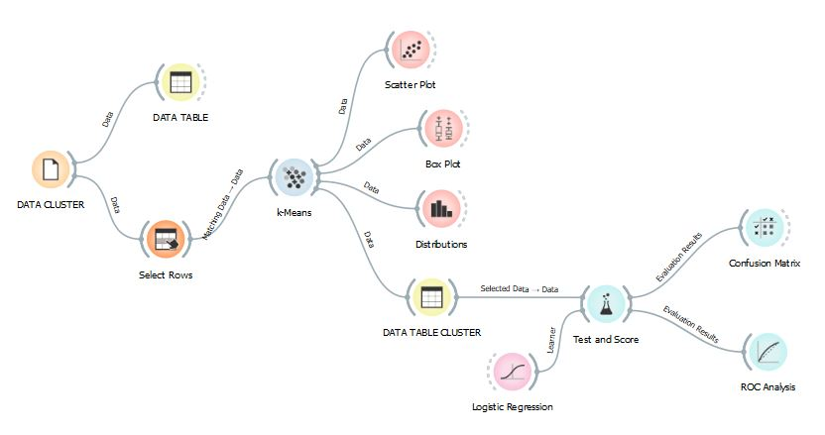

**Fig 2. Model Data Mining**

In the image above is a model designed using the K-Means method in Data Mining. The model above will later be used to carry out Cluster testing of the sample data that has been obtained and the model above will also later be used to evaluate the method used.

## Model Testing and Evaluation in Data Mining

In the testing and evaluation process, the author uses a previously designed model, specifically by applying the K-Means method, a clustering technique that is popular in data mining. The main objective of this test is to group data from visitors to the Happy Kiddy Playground into several clusters based on certain predetermined characteristics, such as age, gender and height. Through the K-Means method, the author can identify certain patterns in visitor data, which will then help in optimizing marketing strategies, adjusting facilities, and improving the overall visitor experience. This testing and evaluation process is key in understanding visitor needs and preferences, enabling Happy Kiddy Playground to provide a more personalized and satisfying service.

## Model Testing Results in Data Mining

The cluster data results for visitors to the Happy Kiddy ride can be seen in the table below.

Table 3. Cluster Results Data

|  |  |  |  |  |  |
| --- | --- | --- | --- | --- | --- |
| **Visitor Name** | **Age** | **Gender** | **Height** | **Category** | **Cluster** |
| Adi Baskara Putra | 6 | Man | 125 | Children | C1 |
| Aisyah Putri Damar | 9 | Woman | 132 | Children | C3 |
| Akbar Rizky Maulana | 8 | Man | 132 | Children | C1 |
| Aldo Bima Seno | 7 | Man | 128 | Children | C1 |
| Alifia Cinta Dewi | 5 | Woman | 117 | Toddler | C3 |
| Bagus Rayhan Aditya | 9 | Man | 132 | Children | C1 |
| Bella Sari Dewi | 8 | Woman | 130 | Children | C3 |
| Bilal Aditya Rahman | 8 | Man | 131 | Children | C1 |
| Bima Dwi Cahya | 7 | Man | 128 | Children | C1 |
| Bintang Rizki Fauzan | 7 | Man | 128 | Children | C1 |
| Cahya Putri Ramadani | 8 | Woman | 130 | Children | C3 |
| Cakra Wijaya Putra | 8 | Man | 130 | Children | C1 |
| Cinta Ayu Lestari | 8 | Woman | 131 | Children | C3 |
| Citra Kirana Sari | 7 | Woman | 128 | Children | C3 |
| Clara Putri Ayudia | 9 | Woman | 134 | Children | C3 |
| Daffa Rizaldi Putra | 8 | Man | 130 | Children | C1 |
| Dara Intan Permata | 6 | Woman | 123 | Children | C3 |
| Dewa Gita Asmara | 8 | Woman | 130 | Children | C3 |
| Dika Jaya Purnama | 6 | Man | 123 | Children | C1 |
| Dina Ayu Safitri | 9 | Woman | 132 | Children | C3 |
| Edo Baskoro Yudhoyono | 6 | Man | 123 | Children | C1 |
| Eka Putra Bramantyo | 8 | Man | 130 | Children | C1 |
| Elang Rajasa Bayu | 7 | Man | 127 | Children | C1 |
| Elisa Nur Aisyah | 7 | Woman | 129 | Children | C3 |
| Elsa Laila Sari | 9 | Woman | 132 | Children | C3 |
| Fadil Jaya Kurniawan | 7 | Man | 126 | Children | C1 |
| Fajar Nugraha Putra | 9 | Man | 132 | Children | C1 |
| Farah Dian Sari | 8 | Woman | 129 | Children | C3 |
| Fikri Jaya Setiawan | 6 | Man | 123 | Children | C1 |
| Fitri Hana Sari | 7 | Woman | 128 | Children | C3 |
| Galih Arjuna Wibowo | 9 | Man | 140 | Children | C1 |
| Ghina Fadhila Yani | 7 | Woman | 128 | Children | C3 |
| Gilang Ramadhan Putra | 7 | Man | 128 | Children | C1 |
| Gina Ayu Kusuma | 6 | Woman | 123 | Children | C3 |
| Giska Putri Illahi | 7 | Woman | 128 | Children | C3 |
| Hadi Surya Baskoro | 7 | Man | 128 | Children | C1 |
| Hana Mei Lestari | 4 | Woman | 100 | Toddler | C2 |
| Hanif Rahmat Pratama | 7 | Man | 128 | Children | C1 |
| Haris Ahmad Syukur | 8 | Man | 128 | Children | C1 |
| Hesti Arum Sari | 7 | Woman | 128 | Children | C3 |
| Ika Melati Indah | 7 | Woman | 128 | Children | C3 |
| Ikbal Fikri Hidayat | 9 | Man | 133 | Children | C1 |
| Indra Bima Yudha | 6 | Man | 123 | Children | C1 |
| Intan Permata Suci | 7 | Woman | 128 | Children | C3 |
| Irfan Zaky Maulana | 8 | Man | 130 | Children | C1 |
| Jaya Kurnia Dewanto | 7 | Man | 128 | Children | C1 |
| Jihan Ayu Pertiwi | 9 | Woman | 132 | Children | C3 |
| Jihan Putri Maharani | 7 | Woman | 127 | Children | C3 |
| Joko Tri Hariyanto | 8 | Man | 130 | Children | C1 |
| Julita Rani Kumala | 5 | Woman | 117 | Toddler | C3 |
| Kafi Adi Pratama | 4 | Man | 103 | Toddler | C2 |
| Kamilia Putri Indah | 5 | Woman | 117 | Toddler | C3 |
| Kania Tiara Putri | 8 | Woman | 131 | Children | C3 |
| Keisha Putri Amalia | 8 | Woman | 130 | Children | C3 |
| Kirana Dewi Salsabila | 9 | Woman | 132 | Children | C3 |
| Laila Cinta Damayanti | 4 | Woman | 103 | Toddler | C2 |
| Liana Dewi Sukmawati | 3 | Woman | 93 | Toddler | C2 |
| Lintang Senja Pratama | 4 | Man | 102 | Toddler | C2 |
| Lutfi Aziz Karim | 5 | Man | 117 | Toddler | C1 |
| Luthfi Ahmad Syahputra | 9 | Man | 132 | Children | C1 |
| Mahesa Jaya Kusuma | 5 | Man | 115 | Toddler | C1 |
| Malik Arjuna Putra | 5 | Man | 117 | Toddler | C1 |
| Maudy Ayu Kusumawati | 3 | Woman | 94 | Toddler | C2 |
| Mika Anggun Permata | 5 | Woman | 117 | Toddler | C3 |
| Mirza Akbar Fauzi | 4 | Man | 103 | Toddler | C2 |
| Nadia Putri Zahra | 3 | Woman | 88 | Toddler | C2 |
| Nanda Rizki Pratama | 4 | Man | 103 | Toddler | C2 |
| Nia Sari Wulandari | 6 | Woman | 126 | Children | C3 |
| Niko Aditya Putra | 5 | Man | 117 | Toddler | C1 |
| Nila Sari Dewi | 3 | Woman | 87 | Toddler | C2 |
| Oka Mahendra Putra | 2 | Man | 75 | Toddler | C2 |
| Olivia Putri Hartanti | 3 | Woman | 89 | Toddler | C2 |
| Olla Ramlan Sari | 6 | Woman | 123 | Children | C3 |
| Opan Jaya Kusuma | 6 | Man | 124 | Children | C1 |
| Ovi Dwi Astuti | 5 | Woman | 117 | Toddler | C3 |
| Prita Kinanti Ayu | 2 | Woman | 76 | Toddler | C2 |
| Puspa Indah Permata | 8 | Woman | 129 | Children | C3 |
| Putra Mahkota Rizal | 5 | Man | 117 | Toddler | C1 |
| Putri Ayu Andini | 6 | Woman | 123 | Children | C3 |
| Putu Bagus Santoso | 6 | Man | 123 | Children | C1 |
| Qaisar Alif Ramadhan | 6 | Man | 122 | Children | C1 |
| Qiara Zafira Husna | 6 | Woman | 123 | Children | C3 |
| Qila Zahra Putri | 2 | Woman | 75 | Toddler | C2 |
| Qisthi Aulia Rahman | 8 | Woman | 130 | Children | C3 |
| Qonita Laila Kurniawan | 6 | Woman | 123 | Children | C3 |
| Rafi Alifian Putra | 6 | Man | 121 | Children | C1 |
| Rama Aditya Pratama | 2 | Man | 78 | Toddler | C2 |
| Rian Dwi Saputra | 6 | Man | 123 | Children | C1 |
| Ridho Bayu Aji | 7 | Man | 125 | Children | C1 |
| Rizki Fajar Nugroho | 8 | Man | 130 | Children | C1 |
| Salsa Bintang Pratiwi | 6 | Woman | 123 | Children | C3 |
| Sari Nindya Ayu | 7 | Woman | 128 | Children | C3 |
| Sasa Tiara Indah | 8 | Woman | 130 | Children | C3 |
| Sinta Bella Ratri | 2 | Woman | 77 | Toddler | C2 |
| Tara Bintang Alam | 2 | Man | 76 | Toddler | C2 |
| Tasya Kamila Putri | 7 | Woman | 128 | Children | C3 |
| Tegar Bayu Pratama | 6 | Man | 123 | Children | C1 |
| Tiara Putri Ananda | 7 | Woman | 128 | Children | C3 |
| Ujang Budi Setiawan | 7 | Man | 128 | Children | C1 |
| Uki Dwi Saputra | 8 | Man | 135 | Children | C1 |
| Umar Zaki Nugroho | 2 | Man | 79 | Toddler | C2 |
| Umi Salma Farida | 7 | Woman | 128 | Children | C3 |
| Vania Kirana Dewi | 6 | Woman | 123 | Children | C3 |
| Vega Arjuna Wisnu | 7 | Man | 128 | Children | C1 |
| Vino Bastian Harahap | 8 | Man | 130 | Children | C1 |
| Vira Ayu Kirana | 3 | Woman | 86 | Toddler | C2 |
| Wafi Aditya Rahman | 6 | Man | 123 | Children | C1 |
| Winda Ayu Larasati | 6 | Woman | 123 | Children | C3 |
| Wira Yudha Pratama | 8 | Man | 130 | Children | C1 |
| Wulan Dari Rahayu | 4 | Woman | 103 | Toddler | C2 |
| Yasmin Nadira Putri | 9 | Woman | 132 | Children | C3 |
| Yasmine Putri Zahra | 6 | Woman | 123 | Children | C3 |
| Yogi Pratama Akbar | 6 | Man | 123 | Children | C1 |
| Yuda Pratama Surya | 6 | Man | 123 | Children | C1 |
| Zahra Nabila Putri | 6 | Woman | 123 | Children | C3 |
| Zaki Ahmad Fauzi | 9 | Man | 132 | Children | C1 |
| Zara Putri Anjani | 7 | Woman | 128 | Children | C3 |
| Zidan Ali Marwan | 7 | Man | 126 | Children | C1 |

In the table above are the cluster results in mining using the k-means method. For the cluster results used, the author used 3 clusters in this research, namely C1, C2 and C3. Of the 118 data used, the results obtained for C1 were 50 data, for C2 the results obtained were 20 data and for C3 the results obtained were 48. Not only cluster results, the author also added several more results such as scatter plot results, boxplot results and distribution. The results will be presented in image form as follows.

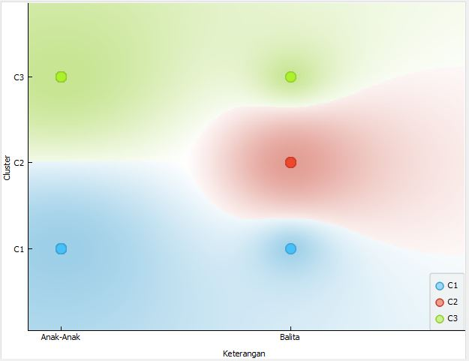

**Fig 3. Scatter Plot Results**

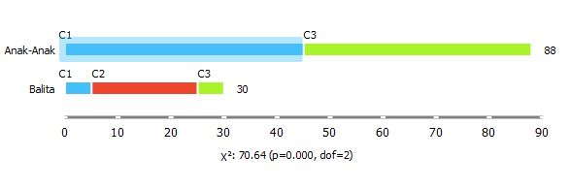

**Fig 4. Box Plot Result**

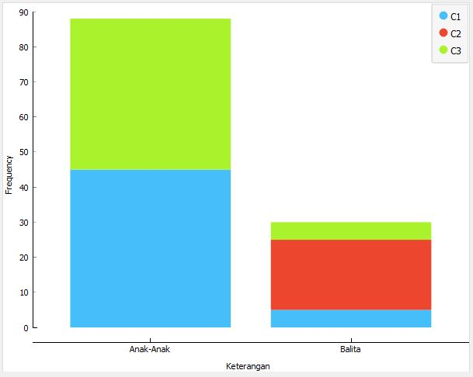

**Fig 5. Distribution results**

## Model Evaluation Results in Data Mining

For the evaluation results, the author uses the evaluation on the Test and Score widget, Confusion Matrix and for the graphic results the author uses ROC Analysis.

***Result of Test and Score***

Table 4. Result of Test and Score

|  |  |  |  |  |  |
| --- | --- | --- | --- | --- | --- |
| Model | AUC | CA | F1 | Precision | Recall |
| K-Means | 1.000 | 1.000 | 1.000 | 1.000 | 1.000 |

The results obtained from the test and score widget are perfect, this is because the AUC results are 1,000, the Ca results are 1,000, the F1 results are 1,000, the Precision results are 1,000 and the Recall results are 1,000. This result was declared perfect because the highest result from the test and score widget was 1,000. At this stage, the choice used by the author is Cross Validation with a Number of Folds of 5.

***Confusion Matrix Results***

Confusion Matrix is ​​a table used to measure model performance, where it visualizes the comparison between predicted values ​​and actual values. The results of this confusion matrix are to test the model using the K-means method which is used to cluster data in data mining.

Table 5. Result of Confusion Matrix

Predicted

Actual

|  |  |  |  |
| --- | --- | --- | --- |
|  | Children | Toddler | ∑ |
| Children | 88 | 0 | 88 |
| Toddler | 0 | 30 | 30 |
| ∑ | 88 | 30 | 118 |

In the table above are the results of the Confusion Matrix, namely the True Positive (TP) result is 88. True Negative (TN) is 30, False Positive (FP) is 0 and False Negative (FN) is 0. So the accuracy, precision and recall values ​​are as follows:

$Accuracy=\frac{88+30}{88+30+0+0}$**+ 100%** Then the Accuracy value = 100%

$Presisi=\frac{88}{88+0}$**+ 100%** Then the Precision value = 100%

$Recall=\frac{88}{88+0}$**+ 100%** Then the Recall value = 100%

***ROC Analysis Results***

ROC Analysis (Receiver Operating Characteristic Analysis) is a statistical method used to measure the effectiveness of a cluster model, by visualizing the relationship between the true positive rate (True Positive Rate) and the false positive rate (False Positive Rate) at various cluster thresholds.

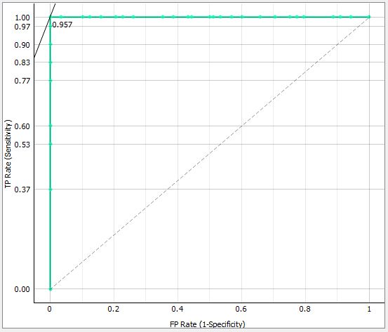

**Fig 6. ROC Toddler Analysis**

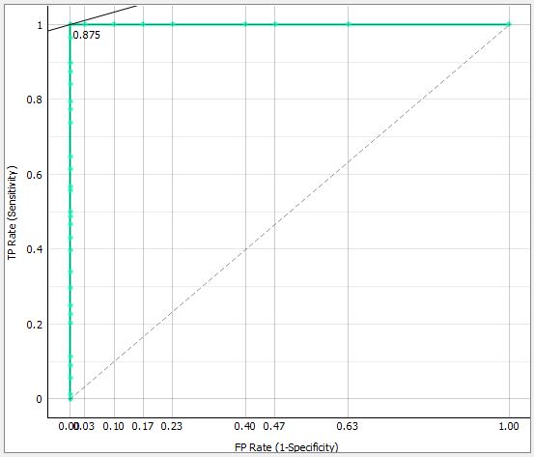

**Fig 7. ROC Analysis of Children**

**DISCUSSIONS**

In research conducted on grouping visitors to the Happy Kiddy Playground using the K-Means method, the author faced several obstacles. One of the main obstacles faced is determining the widgets that will be used in the data mining design model. Choosing the right widget is very crucial because it directly affects the ease of analysis and the accuracy of the results obtained. After going through a careful selection process, the author finally decided on the widget that was most suitable for the needs of this research. From the results of the data grouping carried out, three clusters were identified, namely C1 with a total of 50 data, C2 with a total of 20 data, and C3 with a total of 48 data. This cluster division provides valuable insight into the characteristics of visitors to the Happy Playground. Kiddy, allows the author to better understand the distribution of preferences and behavior of visitors in the playground.

Regarding accuracy results, this study shows interesting results. A comparison of accuracy between the 'Test and Score' widget and the 'Confusion Matrix' widget obtained a ratio of 1:1, where both managed to achieve 100% accuracy. This shows that the two widgets are very effective in predicting and clustering visitor data according to predetermined clusters. The success of achieving 100% accuracy is a strong indicator that the K-Means method, together with selecting the right widget, can be relied on to analyze and group data with a very high level of accuracy. These results not only confirm the effectiveness of the approach taken in this research but also provide an important contribution to similar studies in the future that may face similar obstacles in the selection of data analysis tools.

# **CONCLUSION**

This research makes a significant contribution to the understanding of visitor behavior at the Happy Kiddy Playground, by identifying groups of visitors based on their preferences and characteristics. The success of obtaining 100% accuracy in classification results indicates that data mining techniques, especially the K-Means method, can be relied on as a strong tool in analyzing visitor behavior. These results pave the way for further research in optimizing marketing strategies and development of playgrounds, by focusing on more specific and personalized visitor needs and preferences.

# **REFERENCES**

Abas, M. I., Ibrahim, I., Syahrial, S., Lamusu, R., Baderan, U. S., & Kango, R. (2023). Analysis of Covid-19 Growth Trends Through Data Mining Approach As Decision Support. *Sinkron*, *8*(1), 101–108. https://doi.org/10.33395/sinkron.v8i1.11861

Aji, G. W., & Devi, P. A. R. (2023). Data Mining Implementation For Product Transaction Patterns Using Apriori Method. *Sinkron*, *8*(1), 421–432. https://doi.org/10.33395/sinkron.v8i1.12071

Aldo, D. (2023). Data Mining Sales of Skin Care Products Using the K-Means Method. *Sinkron*, *8*(1), 295–304. https://doi.org/10.33395/sinkron.v8i1.12007

Andi, A., Juliandy, C., & David, D. (2023). Clustering Analysis of Tweets About COVID-19 Using the K-Means Algorithm. *Sinkron*, *8*(1), 543–533. https://doi.org/10.33395/sinkron.v8i1.12145

Asriningtias, S. R., Wulandari, E. R. N., Persijn, M. B., Rosyida, N., & Sutawijaya, B. (2023). Identification of Public Library Visitor Profiles using K-means Algorithm based on The Cluster Validity Index. *Sinkron*, *8*(4), 2615–2626. https://doi.org/10.33395/sinkron.v8i4.12901

Bustomi, Y., Nugraha, A., Juliane, C., & Rahayu, S. (2023). Data Mining Selection of Prospective Government Employees with Employment Agreements using Naive Bayes Classifier. *Sinkron*, *8*(1), 1–8. https://doi.org/10.33395/sinkron.v8i1.11968

Hasibuan, F. F., Dar, M. H., & Yanris, G. J. (2023). Implementation of the Naïve Bayes Method to determine the Level of Consumer Satisfaction. *SinkrOn*, *8*(2), 1000–1011. https://doi.org/10.33395/sinkron.v8i2.12349

Hasibuan, S. A., Sihombing, V., & Nasution, F. A. (2023). Analysis of Community Satisfaction Levels using the Neural Network Method in Data Mining. *Sinkron*, *8*(3), 1724–1735. https://doi.org/10.33395/sinkron.v8i3.12634

Indah, I. C., Sari, M. N., & Dar, M. H. (2023). Application of the K-Means Clustering Agorithm to Group Train Passengers in Labuhanbatu. *SinkrOn*, *8*(2), 825–837. https://doi.org/10.33395/sinkron.v8i2.12260

Mawaddah, A., Dar, M. H., & Yanris, G. J. (2023). Analysis of the SVM Method to Determine the Level of Online Shopping Satisfaction in the Community. *SinkrOn*, *8*(2), 838–855. https://doi.org/10.33395/sinkron.v8i2.12261

Pratama, H. A., Yanris, G. J., Nirmala, M., & Hasibuan, S. (2023). *Implementation of Data Mining for Data Classification of Visitor Satisfaction Levels*. *8*(3), 1832–1851.

Saputra, A. D. S., Hindarto, D., & Haryono, H. (2023). Supervised Learning from Data Mining on Process Data Loggers on Micro-Controllers. *Sinkron*, *8*(1), 157–165. https://doi.org/10.33395/sinkron.v8i1.11942

Sari, M., Yanris, G. J., & Hasibuan, M. N. S. (2023). Analysis of the Neural Network Method to Determine Interest in Buying Pertamax Fuel. *SinkrOn*, *8*(2), 1031–1039. https://doi.org/10.33395/sinkron.v8i2.12292

Sinaga, B., Marpaung, M., Tarigan, I. R. B., & Tania, K. (2023). Implementation of Stock Goods Data Mining Using the Apriori Algorithm. *Sinkron*, *8*(3), 1280–1292. https://doi.org/10.33395/sinkron.v8i3.12852

Siregar, A. P., Irmayani, D., & Sari, M. N. (2023). Analysis of the Naïve Bayes Method for Determining Social Assistance Eligibility Public. *SinkrOn*, *8*(2), 805–817. https://doi.org/10.33395/sinkron.v8i2.12259

Violita, P., Yanris, G. J., & Hasibuan, M. N. S. (2023). Analysis of Visitor Satisfaction Levels Using the K-Nearest Neighbor Method. *SinkrOn*, *8*(2), 898–914. https://doi.org/10.33395/sinkron.v8i2.12257

Wijaya, E. B., Dharma, A., Heyneker, D., & Vanness, J. (2023). Comparison of the K-Means Algorithm and C4.5 Against Sales Data. *SinkrOn*, *8*(2), 741–751. https://doi.org/10.33395/sinkron.v8i2.12224